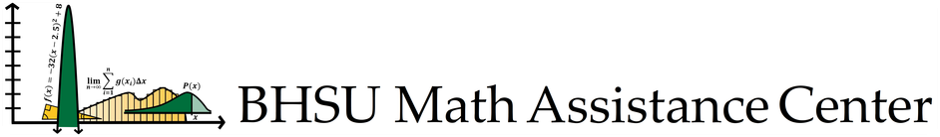

# APPLICATION FOR EMPLOYMENT

MINIMUM REQUIREMENTS FOR APPLICANTS

* Have completed or are currently enrolled in either Calculus I or Intro to Statistics
* Earned at least a C in all previously enrolled math courses
* Have a cumulative GPA of 3.0 or higher
* Be available to attend a mandatory meeting at the beginning of each semester

Tutor job description

The Math Assistance Center (MAC) offers free walk-in tutoring for various math classes. These classes are, but are not limited to: Pre-College Algebra, College Algebra, Quantitative Literacy, Trigonometry, Calculus I, Intro to Statistics, and Elementary Math Methods. Depending on your qualifications, you will be expected to help students with some or all of these courses.

The MAC is open Monday through Thursday from 10:00 a.m. to 8 p.m. and on Friday from 10:00 a.m. to 2 p.m. Math mentors will have a set schedule of when they will be available to work in the MAC.

The math mentors may also have an opportunity to work in a classroom as a mentor. Depending on the professor and the class, the mentor will help in either peer tutoring, proctoring exams, or assist with other classroom activities.

The position pays $12/hour with the opportunity for a pay raise of $0.50 per full year of working in the MAC. The pay raise will only be applied at the beginning of each fall semester.

applicant information

NAME: ____________________________________________ GPA: _________

E-MAIL: _________________________________________________

STUDENT ID: __________________________ Cell phone: _______________________________

Major(s): __________________________________ Minor(s): ______________________________

Year in college qFr qSo qJr qSr qGrad qother:__________________

Expected Graduation date: ____________ Number of work hours per week desired: __________

Are you currently eligible for Work Study? qYes qNo

* If yes, have you accepted it for this year? qYes qNo

Select the courses you would like to tutor

* Pre-College Algebra
* Intermediate College Algebra
* College Algebra
* Mathematical Reasoning
* Trigonometry
* Calculus I
* Introduction to Statistics
* Elementary Math Methods

Math courses

List the college level math classes you have completed or are currently enrolled in this semester. If you have not completed any math college course, please list relevant math high school courses.

|  |  |  |  |
| --- | --- | --- | --- |
| **MATH COURSE** | **SEMESTER/YEAR** | **INSTITUTION** | **LETTER GRADE** |
|  |  |  |  |
|  |  |  |  |
|  |  |  |  |
|  |  |  |  |
|  |  |  |  |
|  |  |  |  |
|  |  |  |  |

Please include any additional comments if needed regarding your coursework.

Short answers

Do you have any recent experience teaching/tutoring? If so, please explain.

Why are you interested in becoming a tutor in the MAC and/or a Math Mentor in the classroom?

Why do you feel you would be a good tutor?

Think about a time when you helped someone academically. What did you do that proved to be most helpful? What did you do that did NOT prove to be particularly helpful? Describe some of the study techniques that you have or will use when you tutor.

What are your goals following graduation?

Faculty reference

(Please be sure to ask the faculty member permission before you use them as a reference.)

Name: ___________________________________ Department: ___________________________

Email: _____________________________________________

Please return this application to either [MAC@BHSU.edu](mailto:MAC@BHSU.edu) or [Erin.Madden@bhsu.edu](mailto:Erin.Madden@bhsu.edu).