BLACK HILLS STATE UNIVERSITY

Travel Manual

This reference guide incorporates South Dakota Codified Law, Administrative Rules of South Dakota, State Auditor policy, and Black Hills State University policy concerning travel. This guide also includes information necessary to properly prepare the travel voucher for reimbursement. It is intended as a resource to answer questions of the traveler and for those responsible for preparation of the vouchers.
Questions may be referred to Anita Haeder in the Budget Office at 642-6566.

Table of Contents
Reimbursement Rate……………………………………………………………………………………………………………………. 1
General Provisions……………………………………………………………………………………………………………………….. 2
Travel Requests……………………………………………………………………………………………………………………………. 3
Ground Transportation………………………………………………………………………………………………………………… 4
Air Transportation………………………………………………………………………………………………………………………… 5
Meals and Lodging……………………………………………………………………………………………………………………….. 6
ADA Exception……………………………………………………………………………………………………………………………… 6.1
Direct Billing Requests………………………………………………………………………………………………………………….. 6.1
Registration Fees………………………………………………………………………………………………………………………….. 7
Prepayment Statement………………………………………………………………………………………………………………… 7
Miscellaneous Expenses………………………………………………………………………………………………………………. 8
Travel Voucher Preparation…………………………………………………………………………………………………………… 9
Travel Payment Detail Information……………………………………………………………………………………………….. 10
Individual Cash Advance……………………………………………………………………………………………………………….. 11
Athletic/Student Activity………………………………………………………………………………………………………………. 12
Travel Detail Examples…………………………………………………………………………………………………………………… 13

Reimbursement Rates Effective September 12, 2022
Transportation Allowances
Transportation Mode Mileage Rate
Personal Auto-Low mileage rate (State Vehicle Available) $0.28 per mile
Personal Auto- High mileage rate (State Vehicle not available) $0.51 per mile
Motorcycle – same mileage reimbursement as personal auto
(ARSD 5:01:02:01)

Private Airplane – Piston Single Engine (per statute mile) $2.50 Private Airplane-Piston Multi-Engine (per statute mile) $4.00
Private Airplane – Turbo Prop Multi-Engine--less than 9 seats (per statute mile) $5.65
(ARSD 5:01:02:07)

Special Needs Mileage Reimbursement - $0.68 per mile for a passenger or cargo
van, pick-up or sports utility vehicle; $0.51 per mile for any other vehicle.
(ARSD 05:01:02:01.01)

Lodging Allowances
Travel Status Daily Allowance Excess Allowance
In-State (ARSD 5:01:02:14) $75.00 plus tax* N/A
Out-Of-State (ARSD 5:01:02:11) $175.00 Plus tax* $100.00 plus tax*
Out-of-Country (ARSD 5:01:02:10:01) $175.00 plus tax* $100.00 plus tax*
Private Trailer House (ARSD 5:01:02:19) $8.00 plus parking fees & electricity** NA
Apartment –requires prior approval from the Finance Office. The rental must result in a savings to the
state to be considered for reimbursement.

Actual cost of lodging may not exceed the pre-approved maximum daily/excess rates.
Questions concerning above the pre-approved maximum rates should be addressed to
Anita Haeder in the Budget Office.
*Normal daily and excess lodging allowance must be on an approved Out-Of-State Travel Request
** Maximum reimbursement may not exceed $26.00 per day.`

1

Meal Allowance
(ARSD 5:01:02:14, 5:01:02:11, 5:01:02:10.01)

Meal In-State Out-Of-State Out of Country
Breakfast $ 6.00 $10.00 $10.00

Noon Lunch $14.00 $18.00 $21.00

Dinner $20.00 $28.00 $29.00

Total Daily Rate $40.00 $56.00 $60.00

Meal Allowance Eligibility
(ARSD 5:01:02:17)

Meal Duty Post Departure Daily Post Arrival
Breakfast Leave before 5:31 am Return after 7:59 am
Noon Lunch Leave before 11:31 am Return after 12:59 pm
Dinner Leave before 5:31 pm Return after 7:59 pm

1.1

General Provisions

Individual Claims Required
Every claimant shall submit a personal and individual claim for his or her travel expenses. One claimant’s travel expenses shall not be a part of another individual’s claim (ARSD 3:05:03:03). This includes sharing a hotel room and payment by one of the individuals sharing the room. The receipt shall be copied and a notation made that it was a shared room and the amount being claimed by each individual shall be written on the receipt. An exception is allowable for faculty advisors and coaches of approved student groups. Please contact the Finance Office regarding these “exception” situations.

Ground Transportation vs. Air Transportation
Any state employee or passenger driving personal or state vehicles out of state to attend conventions/meetings shall be allowed meals and lodging up to two days each way. Car mileage will not exceed the cost of the most economical commercial airfare available per person traveling (ARSD 5:01:02:04). Quotes of available airfare shall be attached to the Out-of-State Travel Request.

Air Transportation
For air transportation there is a one day allowance, within the United States, prior to attending a meeting/convention for meals and lodging

Weekend Layovers
When an employee is required to perform duties in a specific area for a period of time longer than one week, the weekend layover shall not exceed two days. In no event shall the cost of the layover exceed the cost of a round trip to his/her duty station and back. (ARSD 05:01:03:18)

Mileage Reimbursement within City Limits of Home Station
Upon written request of the department head subject to the approval of the appropriate dean/director or vice president, the State Board of Finance may grant approval to specific employees for mileage reimbursement within the city limits of the home work station.

Political and Public Meetings
Under the provisions of SDCL 3-9-7, expenses for attendance of political meetings, fairs and public meetings, are not reimbursable. EXCEPTION: Certain state employees who have agriculture-related assignments to work at the fair may be reimbursed for expenses. Travel vouchers must indicate the specific assignment as justification.

2

Travel Requests
In-State travel requests are not required. However, departments may elect to require travelers to complete the in-state travel requests. A copy of the form that may be used for In-State Travel requests can be found at http://www.bhsu.edu/Portals/0/facultystaff/univ_spt_svcs/BHSU_fillable_travel_request2.pdf

Out-of-State travel requests are required (ARSD 03:05:03:04). Out-of-State travel is any destination point outside of the state’s border. Out-of-State Travel/International Travel Requests shall be submitted via DocuSign and can be found within DocuSign-Templates-Shared Folders-Travel: https://account.docusign.com/#/username Each employee shall complete an Out-of-State Travel Request and shall obtain supervisor and University President/Designee approval. Black Hills State University Administrative Team Members have been assigned Designee approval. Travel Requests are to be directed to the appropriate Administrative Member and shall not require the President’s signature. When completed the requesting party, all signers, and budget office automatically receive a copy.

General Information

Out-of-state travel requests should be approved at least five calendar days prior to the date of travel. If the University is purchasing registration or airfare, the request should be filed early enough that the University may procure those items. The request(s) shall be approved and on file in the Budget Office before requisitions, purchase orders, prepayments of registration fees, direct payments and reimbursement of travel expenses can occur.

University policy requires an out-of-state travel request to be filed when out-of-state or out-of-country business occurs, even if a reimbursement is not claimed, or if a third party is funding the trip. The out-of-state travel request shall be completed with full disclosure of the costs and who is paying for the trip.

Individuals must be on official travel status to be eligible for reimbursement of travel expenses. Travel expenses are not allowable for employees who commute between their home and permanent workstation.

Individuals who are travel out of the country are required, by Board of Regents Policy, to have trip Insurance in place prior to the travel taking place. The individual shall contact the International Engagement Office for insurance information. (BOR Policy 3:14 Student Insurance)

Amended Out-of-State/Out-of-Country Travel Requests

Claims for out-of-state/out-of-country travel must not exceed the cost approved on the travel request. A new out-of-state/out-of-country travel request to amend the original request is required under the following circumstances:

- A different person makes the trip.
- Major changes in itinerary.
- Increase in the cost of total trip. (Cost of the trip includes transportation, airfare, registration, meals, lodging, and miscellaneous expense whether prepaid or not).
- Fund source change. The total amount of the travel costs should be reflected on the request. If the fund source changes, list the breakdown by FOP, Foundation, third-part payer, or personal funds. If funded by two or more sources, please provide the FOP breakdown.
Amended out-of-state/out-of-country travel requests are not required for decreased cost estimates, minor changes in itinerary, and changes in the dates of travel. Cancellation of out-of-state/out-of-country as well as notification of minor changes can be accomplished by contacting Anita Haeder (642-6566) in the Budget Office by email at Anita.Haeder@bhsu.edu

3

Ground Transportation

Distances Between Points Traveled
When transportation is authorized or approved for privately owned vehicles, distances between points traveled shall be standard map miles for direct travel. Odometer readings are required to determine mileage for indirect ground transportation by a privately owned vehicle. (ARSD 03:05:03:14).

Mileage reimbursements for multiple stops during travel must include a physical address. Excess mileage must be justified on the travel voucher.

Privately Owned Automobiles and Motorcycles
Use of privately owned automobiles and motorcycles on official state business will be reimbursed at the rates listed under the Reimbursement Rates section of this manual. The mileage rates cover all expenses incidental to the operation of the vehicle including gasoline, oil, repairs, insurance, towing, and locksmith charges.

Highway/Interstate toll charges and parking costs are not considered incidental expenses to operate a vehicle and may be reimbursed as a separate item with proper receipts.

State Vehicles
State Vehicle reservations or eligibility determinations are made through Facilities Services. The State Vehicle Reservation Form is on-line and are to be completed as early as possible. The link is http://www.bhsu.edu/Faculty-Staff/Campus-Services/Facilities-Services/Vehicle-Requests

If a state vehicle suitable for travel is available and an employee drives a personal vehicle, the employee is reimbursed at the low mileage rate.

An employee is eligible for a reimbursement at the high mileage rate if a state vehicle suitable for travel is not available. A certification of non-availability of a state vehicle, from Facilities Services, must be attached to the travel voucher.

Mileage To and From Air Terminals
Two round trips to a commercial air terminal are allowed when duration of travel is over 24 hours and the commercial air terminal is over twenty miles from the employee’s home or workstation, whichever is closest to the airport. (ARSD 05:01:03:11.) Parking fees in a parking lot and at the airport are reimbursable when accompanied by a proper receipt.

Automobile Rental
Regularly scheduled rates by rent-a-car services is be an allowable charge for transportation on state business if a state or privately owned motor vehicle is not available, providing that a receipt and a statement of justification above requirements is provided with the voucher. (ARSD 05:01:02:06)

Rental of automobiles can be justified only where no other adequate, economical method of transportation (such as taxi, bus, limousine, or private car) is available.
- An individual can make a number of taxicab trips in a day’s time before exceeding the cost of one day’s automobile rental.
- Payment for automobile rentals will not be authorized where a more economical and practical method of transportation is available.
4

- Personal convenience cannot be considered as sufficient justification.
- Extra charges for insurance and liability coverage is not allowable since coverage is provided by the State of South Dakota for employees on state business.
- A statement of justification for car rental services must be attached to the Travel Request and Voucher
A proper receipt and statement of justification must accompany such claims. The State Auditor may disallow car rentals which appears to be for personal use.
Conveyance Vans
Travelers may use conveyance vans for travel to and from the airport in lieu of state or personal vehicles. The traveler may pay the fee and be reimbursed on their travel vouchers with proper receipts. When the University makes direct payment to the van company, the dates of travel, the passenger’s names, and the purpose of the trip must be included on the voucher.

4.1

Air Transportation

Official travel by state employees shall be on the class available that is most economical to the state (ARSD 05:01:02:15). Only one ticket per state employee per trip will be allowable under these rules (ARSD 05:01:02:16). Tickets for employees and students may be purchased in advance by submitting a requisition through SDezBuy (including a copy of the approved travel request and airline quotes} to the Purchasing Office. The Purchasing Office shall approve the requisition and the purchase order is forwarded to the appropriate vendor.

An out-of-state travel request is not required for non-state employees. However, the airfare must be approved by the appropriate department head.

Individuals purchasing tickets with a personal check or credit card will not be reimbursed until the trip has been completed. Reimbursement of airline tickets must have the passenger ticket receipt, the airline itinerary, and boarding passes (if available) attached to the travel voucher.

If an employee uses electronic tickets they are sent a passenger receipt. The invoice-itinerary and the passenger receipt must be submitted with the reimbursement voucher.

Do not combine airfare costs and vehicle mileage costs on the Travel Voucher.

Charter Airplane Rates
Any department, agency, or institution may contact for airplane service from private flying stations when alternative methods of transportation are inadequate when state aircraft are not available. The rates allowed for charter services shall not exceed charges made to private individuals and companies for like services. (ARSD 05:01:02:08). Vouchers for payment of these services must include names of all passengers and a statement of justification.

Private or Rental Aircraft
The mileage reimbursement rates for state employees flying privately owned or rented aircraft while traveling on state business are listed under the “Reimbursement Rates” section of this manual. Mileage is determined by standard air mileage guides. Prior approval of the department head or next level administrator is needed for state employees flying privately-owned or rental aircraft. Travel shall be authorized only for official state business and not to satisfy FAA requirements.

To comply with insurance requirements, any employee who contemplates piloting state-owned, privately owned or rental aircraft shall file three current copies of the following documents to the Finance Office. 1. FAA Pilot Certificates, 2. FAA medial Certificates, and 3. Bi-annual Flight Review.

It is the pilot’s responsibility to maintain qualifications required by the FAA. The State of South Dakota Aircraft Insurance Policy will not extend coverage to employees flying beyond the limitation of the pilot’s license or if the pilot’s certification becomes invalid.

5

Meals and Lodging

Per Diem rates can be found under the “Reimbursement Rates” section of this manual. Any exceptions to lodging per diem regulations require authorization by the State Auditor’s Office. Approval for “over the in-state/out-of-state lodging rates must be obtained in advance of the travel. An email containing 3 hotel quotes sand including the dates of travel, city name, the hotel names, and the quoted prices (without tax) is sent to Anita.Haeder@bhsu.edu who will obtain approval/denial from the Auditor’s Office. The traveler is notified of approval/denial of the request as soon as it is received from the Auditor’s Office.
Continental Breakfasts
Although a complimentary breakfast is included in the cost of lodging, reimbursement for this meal shall not be deducted from the cost of lodging nor the meals reimbursements, unless the traveler desires.

Bed & Breakfast Establishments
The cost of breakfast served at Bed & Breakfast establishments are included in the cost of lodging. The cost of the meal shall be deducted from the cost of lodging and claimed as a meal reimbursement.

Evening Supper Limitations
The evening supper is allowable only to employees whose hours do not conform to normal working hours or who perform special night duties. It does not apply to employees who return late from meetings, seminars or conferences.

Employees Attending Workshops at Home Station
As a general rule, employees attending a workshop located in the city of their home station are not allowed reimbursement for meals. If the workshop registration fee includes the cost of meals, the reimbursement must exclude the cost of meals for employees attending the workshop. Contact the Finance Office for special circumstances.

Out-of-USA Limitations
International travel is not allowed without prior approval. Meals and lodging reimbursements are required to be in US dollars.

Apartment Rental
Rent for apartments will be an allowable expense in UNUSUAL circumstances when an employee is required to be in a specific location other than the employee’s home state for an extend period f time. Rent for an apartment will be allowed in lieu of lodging. Receipts are required. Partial month rental will be pro-rated

Private Trailer House (Camping)
The use of a privately owned trailer house for sleeping accommodations is allowed. Appropriate receipts must substantiate parking fees and electricity charges. The total amount cannot exceed the “Reimbursement Rate” for Private Trailer House under the “Reimbursement Rate” section of this manual.

Miscellaneous
All travelers are expected to pay for their own meals and lodging and to submit personal and individual reimbursement claims. Exceptions to this rule are allowed when paid with a university credit card or by an approved direct billing to the university. The normal daily and excess allowance must be requested and approved on the out-of-state travel request prior to traveling; otherwise, reimbursement will be at the in-state rates.

Lodging in private homes is not reimbursable.

6

ADA Exception to Lodging Rates
The State Board of Finance has adopted an interim policy that permits an exception to lodging rates for qualifying state employees. If an ADA accessible room is available but not at state rate, the qualifying employee shall complete a form provided by the State Board of Finance and attach the form to the travel voucher. The form shall contain the name of the individual requesting the reimbursement, the individual’s agency, the agency address and phone number, the individual’s signature, the signature of the supervisor approving the request and the date of the travel. (ARSD 05:01:02:14.01)

The completed ADA information is forwarded to the Finance Office. Final approval authority rests with the State Board of Finance. Requests will be considered at the regularly scheduled meeting, with is the third Tuesday of each month. If time requires immediate approval, the Finance Office will fax the form and obtain telephone approval.
The State Board of Finance will notify the agency of its decision. The approved ADA travel information shall be attached to the travel voucher.

ADA exceptions to lodging rates require prior approval. The State Board of Finance will consider all request for ADA exceptions on a case-by-case basis. The policy also applies to qualifying students, interview, candidates, and other on-state employees. For assistance, contact the Business Services Director (642-6562).

PREPAID HOTEL RECEIPTS AND INFORMATION
Should lodging be prepaid, either by the university or the traveler, a receipt is required. In addition, proof of the dates that the traveler checks in to the hotel and the date checked out of the hotel are required.

Direct Motel/Hotel Billings
Payments for lodging by state agencies directly to the motel or hotel are allowed. Should an individual or group of individuals request direct payment to a motel/hotel, the Finance Office shall be contacted to determine that direct billing has been established. Please be aware of the following requirements:

- Direct payments to the motel will be limited to the approved state rates for lodging and will not include tax.
- Extraneous expenditures such as meals or telephone cannot be charged to the motel room.
- Voucher payment to the motel should be cross-referenced on the travel vouchers for individuals.
Both documents must include the names of the individuals and the dates of their stays.

The form to request direct billing can be found in DocuSign-Templates-Shared Folders-Finance or Travel at https://account.docusign.com

BHSU Students on official university business are covered by the policy as well as BHSU employees.

6.1

Registration Fees

Registration fees for meetings shall constitute a reimbursable expense if the state employee was authorized to attend on behalf of state business (ARSD 05:01:02:22). The cost of meals and lodging which is included in the registration shall be deducted from the registration fee and included as per diem based on rates allowed (ARSD 05:01:02:23). However, one banquet fee per registration fee will be allowable in lieu of reimbursement regular reimbursement allowance. Meal reimbursement rates are found in the “Meal Allowance: section of this manual.
Registration fees may be prepaid either by completing a requisition (with approved travel request and registration form attached), by the individual traveler or by a Request for Payment. In order to do so, the Request for Payment form must be completed, with a copy of the registration form/invoice attached. If the travel is out of state, the out-of-state travel request must be approved and on file prior to the Request for Payment to be made. A complete agenda or a copy of the registration form showing the costs included must be attached to the Request for Payment form to make the prepayment.
When preparing the individual’s travel reimbursement voucher, the following items should be taken into consideration:
- A copy of the registration form with breakdown of costs, if available, must be attached to the voucher.
- If the employee as part of the registration fee paid meals and/or lodging, those meals and/or lodging must be deducted from the registration fee and included as meal per diem based on the rates allowed.
- If meals were included as part of a prepaid registration fee, the meals per diem for the day must be reduced.
- Only one excess meal fee (banquet) is allowed per registration if the amount can be determined from the receipt or registration form. Proper receipts must be included to verify payment of the fee. The portion of the meal fee that is in excess of the authorized meal rate should be claimed as an incidental expense.
- A copy of the program or official letter giving dates and location must be attached to the travel voucher.

Prepayment Statement
For Out-of-State travel, the Missed Workshop Statement is included on the Travel Request that is found in DocuSign-Templates-Travel or Finance Shared Folder at https://account.docusign.com
For in-state travel, the In-State Missed Workshop statement can be found in DocuSign-Templates-Shared Folders-Travel or Finance at https://account.docusign.com
A copy of the completed Missed workshop Statement for in-state travel must be attached to the travel detail form when submitted for reimbursement.

7

Miscellaneous Expenses

Travel by Non-State Employees
Persons who are not state employees, but who travel on behalf of state business, in-state or out-of-state, shall be reimbursed for the expenses of lodging, meals and travel, not to exceed the maximum allowed for state employees on similar travel. All claims with substantiating documents must be submitted on the standard voucher and be approved as required of other travel vouchers. A W-9 Request for Taxpayer Identification Number form should be filled out by the individual in order to make reimbursement. Requests for W-9 shall be made with Accounts Payable in the Finance Office and should include the name and email address of the individual in order that a DocuSign W-9 Request can be sent to that individual.

Interviews
At the discretion of the department conducting the interview, candidates may be reimbursed for transportation, lodging and meals not to exceed the applicable in-state rates. Travel costs incurred by the candidate’s spouse, dependents and significant others are not allowable expenditures of University funds. Such expenses may be paid from Institutional Representation, Foundation or private funds. Travel costs incurred by a current state employee for an interagency interview are not allowable expenditure of University funds.

Taxi Fare
Taxi fares are allowable expenses. Receipts are not required if the amount is $5.00 or less. Taxi fares to and from eating establishments may not be allowed. Vouchers must indicate point of origin and destination for each trip.

Telephone Calls
Telephone calls relating to state business are allowable. The name and telephone number of the person called and the purpose of the call must be documented on the Travel Payment Detail form. Telephone calls of a personal nature, to home or to relatives, are not allowable.

Tips and Gratuities
Tips and gratuities are not reimbursable as they are a personal expense.

Fuel Purchases
Claims for fuel purchased for state vehicles must be accompanied by the credit card receipt or a paid receipt signed by the vendor. Claims shall be made on a “Request for Payment” form and submitted to Facilities Services for payment.

Miscellaneous
Other expenses directly related to the travel being performed may be allowable. This would include baggage transfer, toll charges, fuel for rented or state vehicles, etc. Equipment and/or material normally purchased through other methods will not be allowed. Receipts are not required if the item cost is less than $1.00 per occurrence.

An employee who engages in interrupted or indirect travel is considered to be returned to state business when the employee arrives back at the point from which the employee left duty status or at some point equidistant or nearer to the point of destination (ARSD 05:01:13:15).

8

Travel Voucher Preparation

The one-page Travel Voucher (located on the employee Snap page) will be used for reimbursement of travel expenses. If additional room is needed for description of travel, lines by be added via Excel or a like program. Typewritten forms are desirable, however, legible hand-written or printed voucher are acceptable providing that all copies are legible.

Each claimant shall submit a personal and individual claim for his or her travel expenses. One claimant’s travel expenses shall not be a part of another individual’s claim. (ARSD 03:05:03:03)

Original copies of receipts off expenditures in excess of one dollar except in cases of taxi fares under five dollars, including lodging but excluding meals, shall be submitted in support of claims for reimbursements. When the vendor requires the original copy for his files, the second copy shall be accepted by the auditor (ARSD 03:05:03:10)

Delayed Travel Reimbursement Request
Pursuant to Administrative Rule 3:05:03:03.1 Voucher Submission timing. A claim for travel expenses must be received by the state auditor within 60 days after the last date of travel. If this timeline is not met, written documentation on a form provided by the state auditor must be submitted by the claimant stating the reason for the delay in submitting the claim prior to determination by state auditor on allowance of the claim. The form must be signed by the head of a state agency, bureau, or any office from which the claimant is seeking reimbursement. If the claimant is a department secretary or bureau commissioner, the form must be signed by the Governor.

The Delayed Travel form is found in DocuSign-Templates-Shared Folders-Travel or Finance at the below link: https://account.docusign.com A copy of the front page of the travel detail form can be attached and the original travel detail forwarded to the Budget Office. Once completed, a copy of the Delayed Travel form completed in DocuSign is automatically returned to all individual and the Budget Office.

In-State Travel
An employee who frequently travels in-state may submit one travel reimbursement form for multiple trips. Submissions of the travel reimbursement form on a monthly basis is suggested.

Out-Of-State
Each out-of-state trip must be submitted on a single travel reimbursement form. A trip is defined as leaving the work/home station and returning to the work/home station.

Example One: Trip from Pierre to San Francisco – for two days- and return to Pierre would be submitted on a single reimbursement form.

Example Two: Trip from Pierre to Denver – for two days – to San Francisco – for three days- and return to Pierre would be submitted on a single reimbursement form.

The out-of-state travel request form must accompany the travel payment detail form or be on file in the Budget/Finance Office.

9

Travel Payment Detail Form

The travel payment detail shall contain the following information:
- The Payee Name, Institution & Department Name, Employee Banner ID, Home Station, and the auto license number if a personal vehicle was used for travel.
- The beginning date/month of travel.
- Description of Travel/Destination.
- Time and date the individual left on the date travel begins and time and date the individual returns on the date travel ends (ARSD 5:01:03:14)
- Expenses for each day of travel shall be listed on the travel detail form for all travel. Dates/information shall not be listed as a lump sum.
- Auto miles (if a personal vehicle was used)
- Transportation Cost for personal auto, taxi, personally paid airfare, subway etc.
- Meal costs – Cost for meals. However, if any meals are included in a registration, those meals cannot be claimed on the travel detail form. One banquet is allowed with appropriate documentation.
- Lodging costs – Lodging costs should be broken down each day. As a reminder, if the lodging cost is at the maximum allowed reimbursement, the charges for a safe cannot be reimbursed.
- Miscellaneous expense: Items in this category may be hotel/motel parking charges, internet charges tied to a room charge, as well as items that do not fit into any of the other categories.
- Tips and gratuities for taxi/meals etc. cannot be reimbursed and should be removed from the reimbursement costs prior to filing the form for reimbursement.
- Receipts – all receipts should be the originals if possible as required by the state auditor’s office (ARSD 3:05:03:10). Receipts for meals are not required as the state reimburses a per-diem amount.
- A copy of the agenda for a conference, workshop, or meeting shall be attached. If the agenda is lengthy, a copy of the “Schedule at a Glance” may be used.
- A copy of the in-state Missed Workshop form (If applicable) must be attached to the travel payment detail form.
- Boarding passes for airline travel shall be attached. Boarding passes, if available, may be a printed copy provided by the airline or a printed form from an electronic device is also acceptable.
- The traveler shall sign on the claimant signature line. The form also requires an authorizing signature to be completed. Administrative Team Members have been delegated the authority to sign the authorizing signature line if needed. Travel Detail forms shall not be sent to the President’s Office for signature.
- The Grand Total and Amount Reimbursable spaces shall be completed. If a traveler obtained a travel advance through the university, the amount of the advance shall be shown in the “Apply to Advance” line. The amount Reimbursable Space would be the Grand Total less the” Apply to Advance” line.
- Interrupted Travel - In case an employee, for his or her convenience, travels by an indirect route or interrupts travel by direct route, the expenses shall be based on such charges as would have been incurred by a usually traveled route. The date and hour of leaving travel status and the date and hour of return to travel status (with respective odometer readings, if applicable) shall be shown on the travel detail. Return to duty status must be at the point which traveler left duty status or at some point equidistant near the point of flight. When weather or plane conditions cause interrupted flight and the expenses are absorbed by the airlines, no payment for meals or lodging will be made. Expenses for the first twenty-four hours are absorbed by the airlines.
10

- Registration for conferences – if a requisition was used for the purchase, a copy of that requisition or purchase order along with a copy of the registration form shall be attached. If paid by an individual, a receipt is required along with a copy of the registration form.
- Conference attendees: a copy of the agenda is required to be attached to the travel payment detail. If attending a meeting that has an agenda, a copy of that agenda shall also be attached. (ARDS 03:05:03:02)

10.1

Individual Cash Advance

Individual cash advances are allowed, if needed. Per State rules (ARSD 39:01:02:04), advances are subject to a $200.00 minimum and a $2000.00 maximum.

The Individual Travel Advance Request form is found in DocuSign –Templates-Shared Folders-Finance or Travel at:
https://account.docusign.com

Cash advance requests shall be completed at least ten (10) working days in advance of the requested travel date. The completed form through DocuSign is automatically submitted to Accounts Payable in the Finance Office. Deposits of the cash advance are made directly to the requesting employee’s bank account and are processed within one week prior to departure.

A cash advance will be limited to 80% of expenses excluding amounts prepaid, covered by a purchase order and/or mileage when using a state vehicle.

Upon return from the trip, a travel reimbursement (travel payment detail) form shall be completed and submitted within thirty (30) days of the traveler’s return. Travel detail forms received for audit after 60 days from the last date of travel shall be accompanied by the “Delayed Travel Reimbursement Form” that is competed by the traveler. The form can be found in DocuSign-Templates-Shared Folders-Finance or Travel at: https://account.docusign.com

The amount of the cash advance shall be placed on the line title “Apply to Advance” under the Grand Total on the travel payment detail form. The advance amount is then deducted from the grand total and placed on the “Amount Reimbursable” line.

11

Athletics/Student Activity Travel Advance

Faculty and staff who travel with students may request a cash (travel) advance for some the student travel expenses.
The Athletics/Student Travel Advance form is available in DocuSign-Templates-Shared Folders-Finance or Travel at the following link https://account.docusign.com

A copy of the approved travel request and a list of all individuals traveling must be attached.

The Athletics/Student Activity Travel Advance is a personal liability for the faculty/staff member making the request. Requests for Athletics/Student Activity Travel Advances shall be submitted to Accounts Payable in the Finance Office at least 10 working days prior to the date of the requested travel. Earlier submission is appreciated.

The Athletics/Student Activity Travel Advance must be reconciled/repaid within thirty (30) days of the traveler’s return. Original receipts/documents and any remaining dollars shall be delivered to Accounts Payable for reconciliation. Please plan to spend some time with the Accounts Payable staff to make certain that all documents are in order.

University issued credit cards may be used for student travel only.

12

EXAMPLES

Below are examples of travel details that were received for audit, what appeared on the corrected form and an example of what would have been the best-completed form.

Received – JOHN SMITH

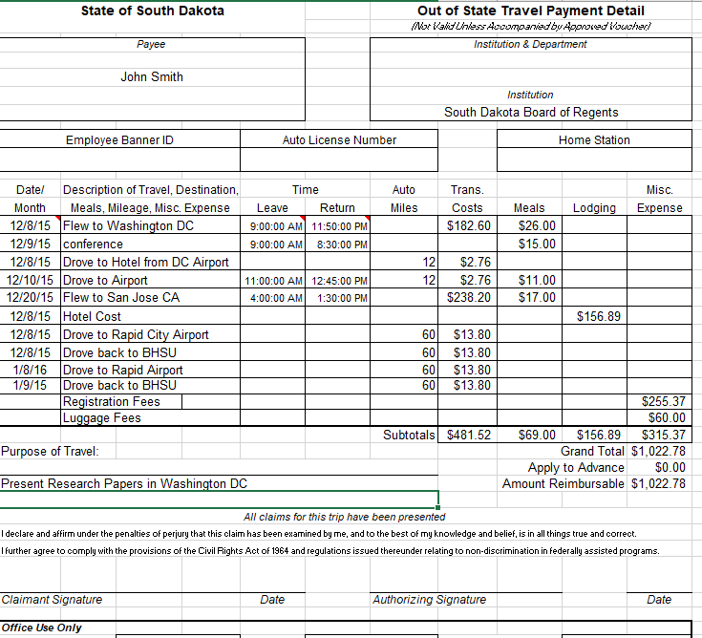
13
As Corrected – JOHN SMITH

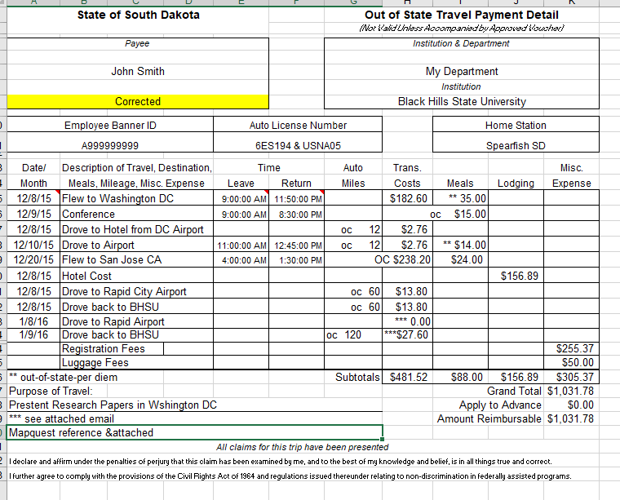

13.1

Best – JOHN SMITH

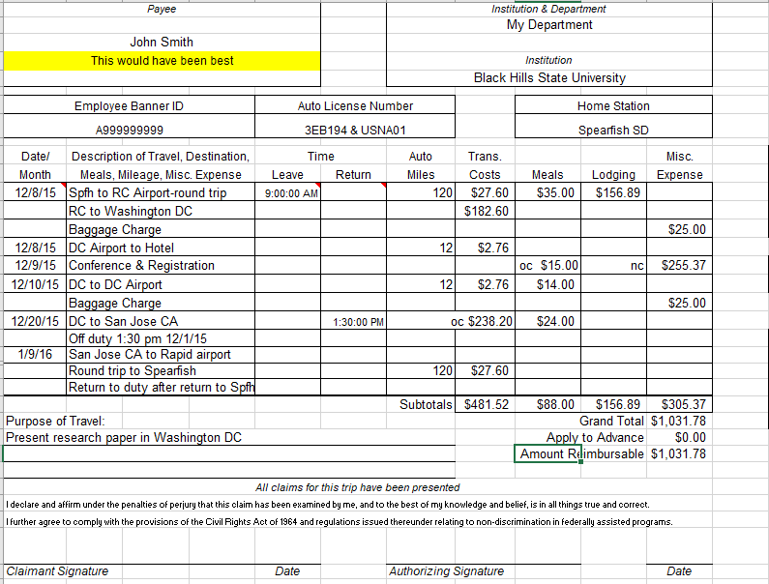

13.2

