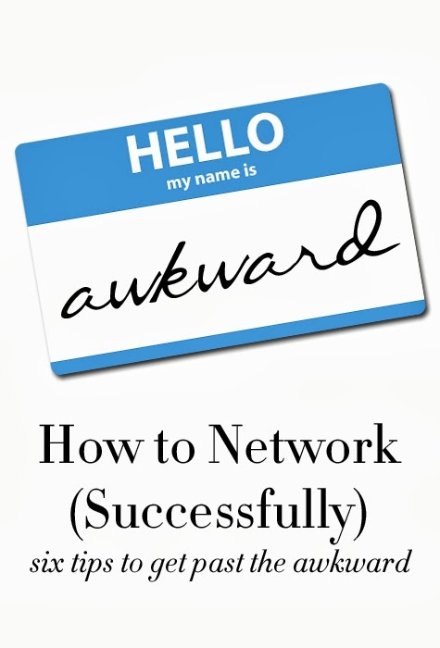
Networking in college

1. It's not networking (it's connecting). Forget about collecting as many business cards as possible and instead focus on making connections. Even if it’s in a professional context, these relationships should be pretty close to a friendship! (Friendships come in all shapes and sizes!)

2. Be yourself. If you're loud and funny, be loud and funny. If you're shy and awkward, it's okay to be awkward and quieter. Knowing that you can be yourself and not have to worry about acting in a way you think you should act will instantly calm you down. A bit, at least. Don't worry about what you think you should do... Just relax and know it’s okay to be yourself. In fact, it's WAY better to be yourself. Always. When you're yourself, you'll make a genuine connection.

- Smile. It makes you approachable. No one wants to up to someone with a glum face. Smile and say hi to ten new people each day.
- Say someone’s name when you meet them. Not only are you more likely to remember their name the more you say it, but everyone likes hearing their own name.

3. Ask questions (and listen). Human truth: people like talking about themselves. Want to get a conversation going? Ask a question. Or two. Keep asking questions. You'll learn so much about the other person. Plus, there is no better way to show interest by asking smart questions. Oh, and to ask smart questions... you have to listen. Follow-up questions should never be something that the person already said. Yikes.

4. Prepare a few safe topics ahead of time. In the morning, I come up with three things that I could talk to about with someone if I find myself in a situation where I feel uncomfortable. Some examples: New restaurants you want to try or just visited, an exhibit that opened up in the city, a new life event (like your new job or a new project), something in the news (but avoid religious and political topics)... etc. I always back-pocket three topics so I know I'll always have something to talk about. No matter what.
**What are some topics you could discuss with someone?

5. Reach out to anyone (and everyone). Want to pick someone's brain? Ask him to coffee. Just dying to know how she does it all? Ask. See someone at an event that you've always looked up to? Introduce yourself. It takes work and effort... but it's worth it. Don't wait for someone to come up to you or to reach out to you. Go for it.

- Ask about leads (job opportunities)
- Information
- Advice
- Referrals (other people they can introduce you to that you should meet).

6. It's okay if you don't "click" with someone. I generally meet with eight to ten different people throughout a normal week. Half of the time, I'm meeting complete strangers. Almost always we hit it off or get through the meeting with amazing end results. BUT, from time to time, we don't click. I used to get really annoyed with myself... thinking that I did absolutely everything wrong. But you know what? Sometimes the synergy is just not there and that is okay. Focus on the connections that work instead of beating yourself up over the connections that don't.

A few more helpful tips:
- Research and attend networking events held by your organization.
- Contact your fellow alumni groups. Most universities have a department dedicated solely to alumni that can be useful. Research contacts in your field, even if they didn’t graduate in the same year as you.
- Get involved in your organization. Join a committee. The organization offers a natural connection amongst its members. You’ll meet people who will offer you advice and help you collaborate on ideas and projects.

So how do you start a conversation with a random stranger?
Try these conversation starters:
- Hi, I don't know too many people here, so I wanted to introduce myself. I'm [name] and I work at [company]." And bam—you got it.
- “So, what do you do?" It gets them talking first and you can think about how to approach the conversation or how you could possibly work together.
- “So, what brought you here today?”
- "How's your day going?" This is my go-to in any situation, and it never fails. It's simple, classic, and always effective if you throw in a smile.
- "What's your story?" It always sparks a fascinating and non-generic conversation.
- "What a beautiful venue. Have you been here before?"
- "I’m feeling pretty overwhelmed by the deluge of info that’s being firehosed at us today. Is there one nugget of brilliance that’s really resonating with you?"
- “It's so hot (or cold) in here.” Hey, maybe it is, maybe it isn’t, but the person will either agree or disagree, and pretty soon you’re talking about weather patterns, your best umbrella, and then your career goals.
- "How did you hear about this event?"
- "As we're both here at the (buffet, bar, waiting room), I feel I should introduce myself. I'm [name] from [company]."
- I like to compliment people on their clothes and accessories. I find this approach to be more friendly and less about professionally connecting, especially if you're at a networking event. I believe both men and women can compliment each other on their choice of attire and use it as a conversation starter!
- "I'm trying to make myself meet new people here instead of just talking to the usual suspects. Do you mind me saying hello and introducing myself?"
- “Man, I hate networking.” If you sense a fellow party-goer has similar misanthropic tendencies, walk up and start a conversation about your mutual distaste.
- "I'll be honest, the only person I know here is the bartender, and I just met him two minutes ago. Mind if I introduce myself?"
- "Any chance you know a great sushi place around here? I'm not familiar with the area, and I'm headed to dinner after this."
- “Hey, aren’t you friends with [fill in random name]?” It doesn’t matter if you really think the person is someone you know, just walk up and ask if he or she is friends with someone you know. He or she will tell you “no,” and conversation will commence.
