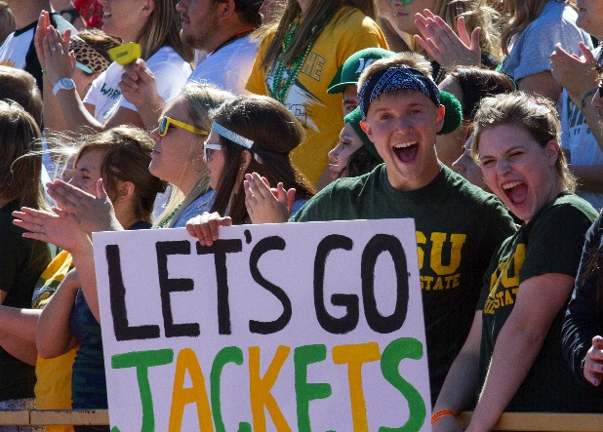BHSU_logo_PMS349_PMS123

Black Hills State University invites you to

**Your Headline Here**

**Date**

Location

City, State

*Very brief information, i.e., cost, open to the public, reservations required, etc.*

For questions or for more information about this event contact April Meeker at (605) 642-6426 or April.Meeker@BHSU.edu.

For complete details visit   
[www.BHSU.edu/Commencement](http://www.BHSU.edu/Commencement)

**\_\_\_\_\_\_\_\_\_\_\_\_\_\_\_\_\_\_\_\_\_\_\_\_\_\_\_\_\_\_\_\_\_\_\_\_\_\_\_**

**Black Hills State University**

*Where anything is possible.*

Persons with disabilities requesting accommodations for this event should call Contact Name at

Phone Number at least 48 hours prior to the start of the event.