*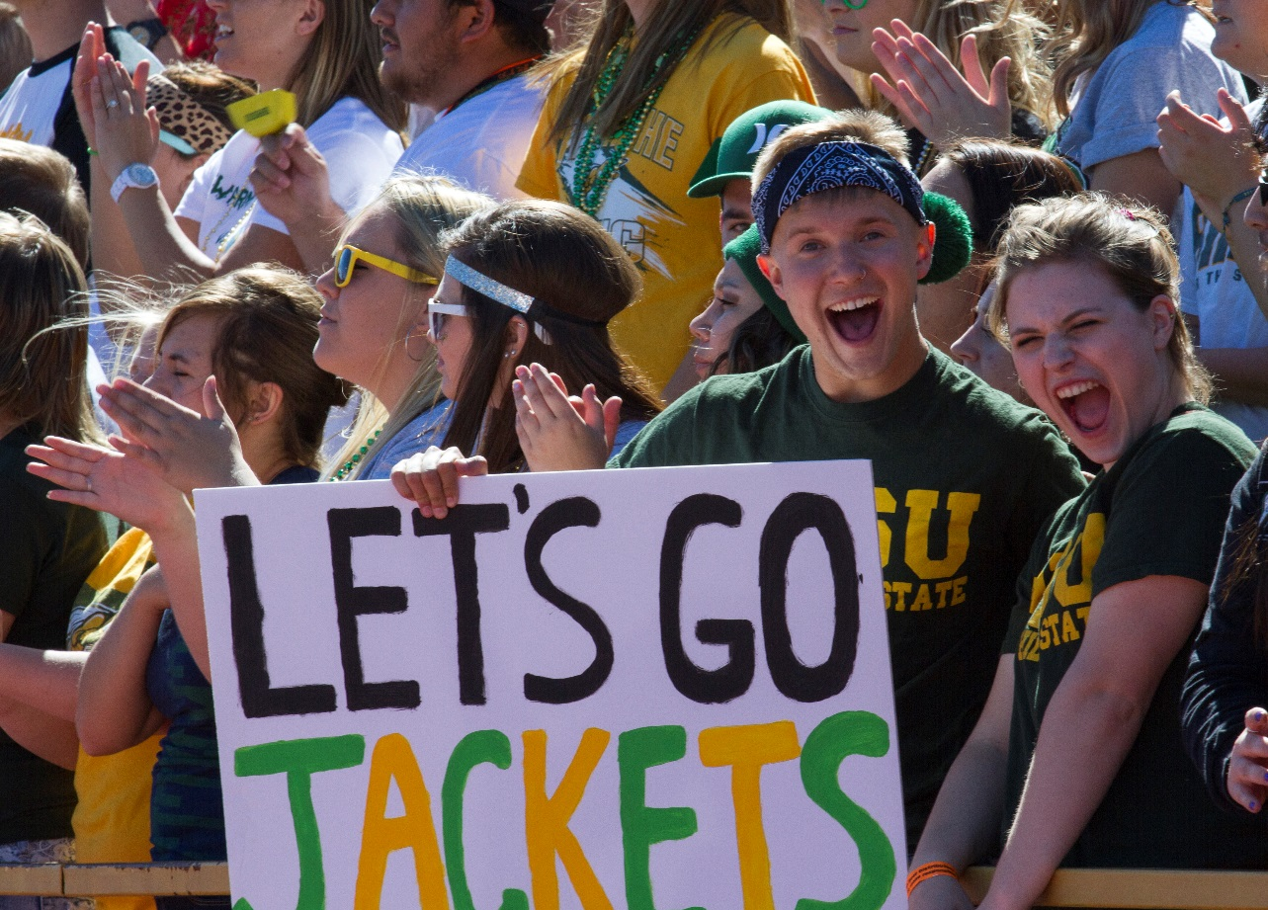BHSU_logo_PMS349_PMS123*

**Date**

Location

City, State

*Very brief information, i.e., cost, open to the public, reservations required, etc.*

For questions or for more information about this event call contact name at (605) 642-6426 or email to email address.

For complete details visit www.BHSU.edu/Commencement

**\_\_\_\_\_\_\_\_\_\_\_\_\_\_\_\_\_\_\_\_\_\_\_\_\_\_\_\_\_\_\_\_\_\_\_\_\_\_\_\_\_\_\_\_\_\_\_\_\_\_\_\_\_\_\_**

**Black Hills State University**

*Where anything is possible.*

Black Hills State University invites you to

**Your Headline Here**

**\_\_\_\_\_\_\_\_\_\_\_\_\_\_\_\_\_\_\_\_\_\_\_\_\_\_\_\_\_\_\_\_\_\_\_\_\_\_\_\_\_\_\_\_\_\_\_\_\_\_\_\_\_\_\_**

**Black Hills State University**

*Where anything is possible.*

Persons with disabilities requesting accommodations for this event should call Contact Name at Phone Number at least 48 hours prior to the start of the event.

.