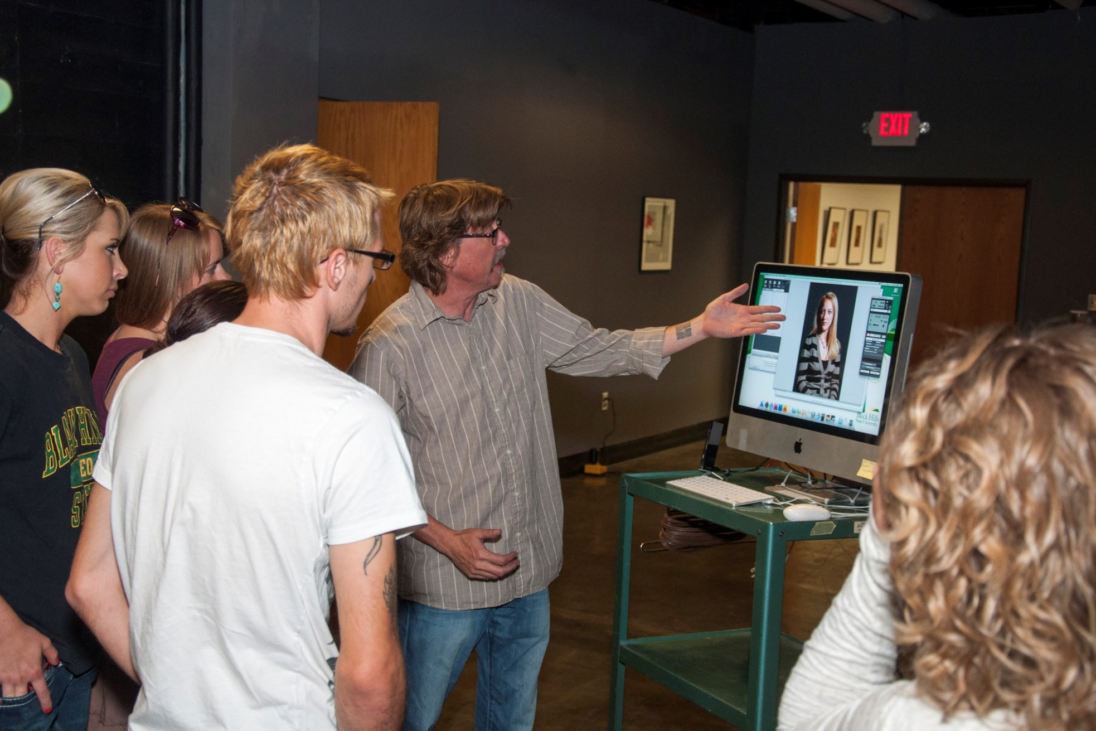

Persons with disabilities requesting accommodations for this event should call Contact Name at Phone Number at least 48 hours prior to the start of the event.

.

***Where Anything is Possible***

For more information

visit www.BHSU.edu/

Event Details

DATE / tiME / LOCATIOn

**Your event name here**