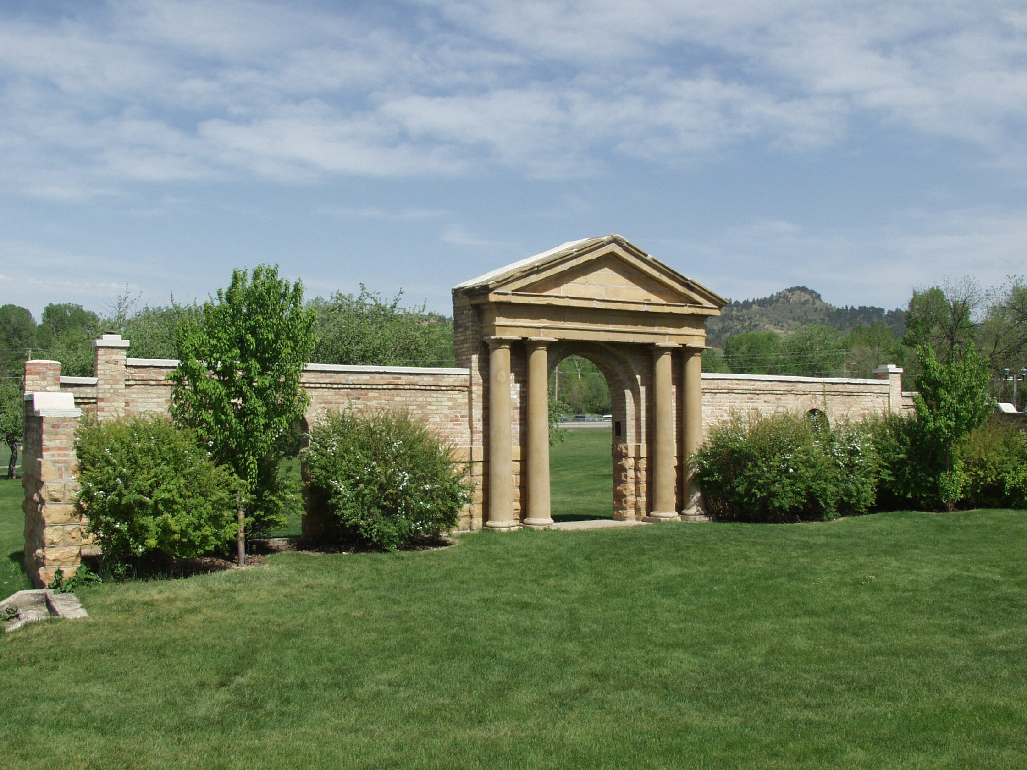

Persons with disabilities requesting accommodations for this event should call Contact Name at Phone Number at least 48 hours prior to the start of the event.

.

***Where Anything is Possible***

**Your Event**

**Name Here**

**Event details here, like time, overview – and replace the photo with your own**

**Room 100**